Sharon Raj
Prof: Dr. Surani Matharaarachchi | New York Tech | Programming for Data Science
Classification and Model Comparisons
DTSC 610- Final Project

Employee burnout negatively affects employee well-being, productivity, and organizational performance. (Maslach & Leiter, 2016). This project investigates whether machine learning models can accurately predict employee burnout using a synthetic Human Resources dataset obtained from Kaggle (Kaggle, n.d.). Exploratory data analysis (EDA) was conducted to understand the characteristics of the data, followed by preprocessing including one-hot encoding, feature scaling where appropriate, train-test splitting, and Synthetic Minority Oversampling Technique (SMOTE) to address class imbalance. Seven classification algorithms were evaluated: Logistic Regression, Decision Tree, Random Forest, K-Nearest Neighbours (KNN), Support Vector Machine (SVM), Gradient Boosting, and Naïve Bayes. Models were compared using Accuracy, Precision, Recall, F1-score, ROC-AUC, and confusion matrices. Decision Tree and Gradient Boosting achieved the strongest overall performance with 99.75% accuracy, 100% precision, 96.15% recall, and an F1-score of 0.9804. The results demonstrate the value of machine learning for supporting Human Resources decision-making by identifying employees at risk of burnout.

I. Introduction and Problem Definition
Problem Statement: The objective of this project is to predict whether an employee is experiencing burnout (Burnout = 1) or not (Burnout = 0) using demographic, workplace, and well-being characteristics.
Business Motivation: Employee burnout contributes to absenteeism, reduced productivity, lower engagement, and increased turnover. Predictive analytics enables organizations to identify at-risk employees earlier and provide targeted interventions.
Dataset Description: A synthetic HR burnout dataset from Kaggle containing 2,000 employee records. The target variable is Burnout (0 = No Burnout, 1 = Burnout).
-Key predictors include Age, Gender, Experience, Job Role, WorkHoursPerWeek, RemoteRatio, SatisfactionLevel, and StressLevel.
-Numeric variables include Age, Experience, WorkHoursPerWeek, RemoteRatio, SatisfactionLevel, and StressLevel.
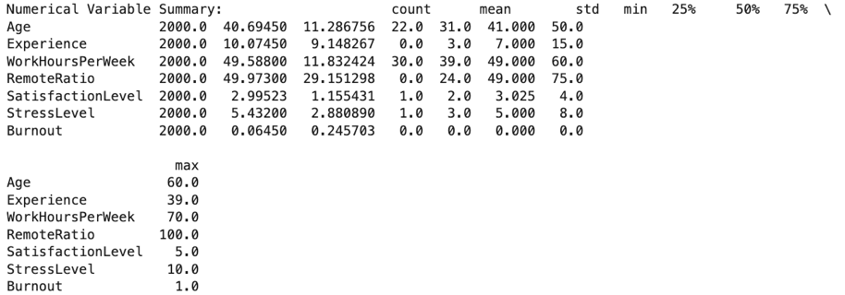
- Categorical variables Gender and JobRole.
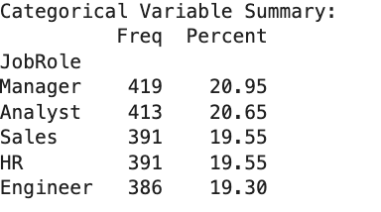
A few rows of data are present below for a visual:
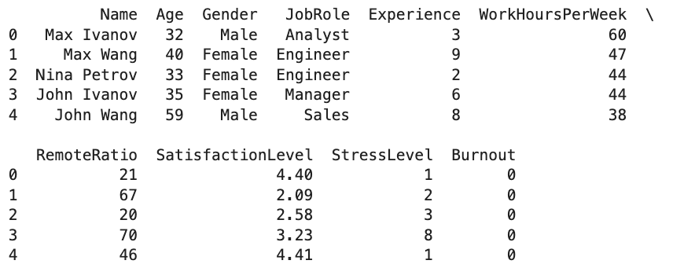

II. Data Cleaning and Preprocessing
The dataset contained 2000 observations with 10 variables. There are no missing values, duplicate observations, or invalid ranges; therefore, no major data cleaning was required. Categorical variables were converted using one-hot encoding. Numerical features were standardized for algorithms sensitive to feature scaling, including Logistic Regression, KNN, and SVM. The dataset was split into 80% for training and 20% for testing, using a fixed random state to ensure reproducibility. The original training data contained 1,871 non-burnout observations and 129 burnout observations. Due to severe imbalance, the data was split into 1600 training samples and 400 test samples before SMOTE was applied (Chawla et al., 2002). Before SMOTE, the counts were 1497 non-burnout and 103 burnout. SMOTE was applied to balance the training data, resulting in 1,497 observations per class.
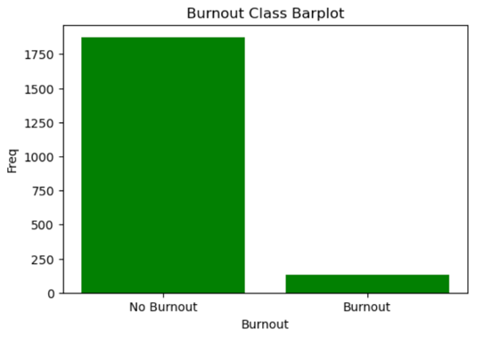
The dataset was split using random_state=42, SMOTE was applied with random_state=42, and the machine learning models were trained using fixed random states (42 for most models and 787 for the Decision Tree). Using fixed random seeds ensures that the same results can be reproduced when the analysis is rerun.
The results of this check are provided below for a visual:
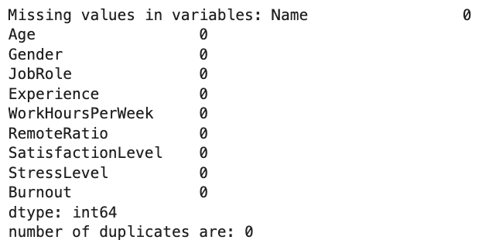 | 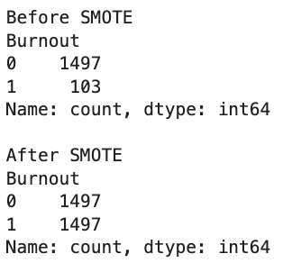

III. Exploratory Data Analysis and Simple Statistics
Exploratory analysis indicated that employees experiencing burnout generally reported higher stress levels, longer working hours, and lower job satisfaction than employees without burnout. Histograms, boxplots, bar charts, and a correlation heatmap were used to explore variable distributions and relationships. The target variable was highly imbalanced, making class balancing necessary before model training. The EDA suggested that StressLevel, SatisfactionLevel, and WorkHoursPerWeek were the strongest predictors of burnout.

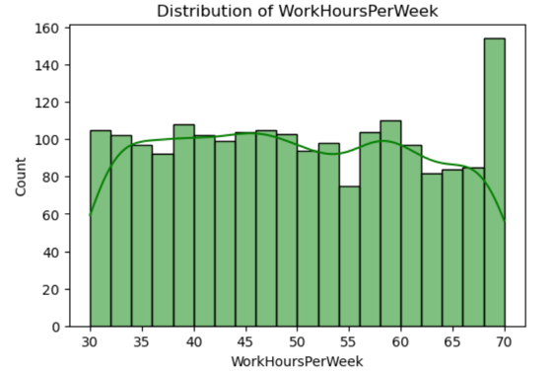 | 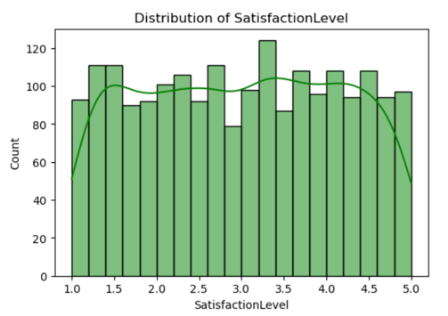 | 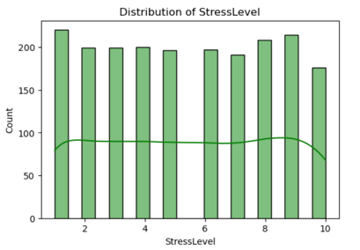

Association between categorical feature and target:
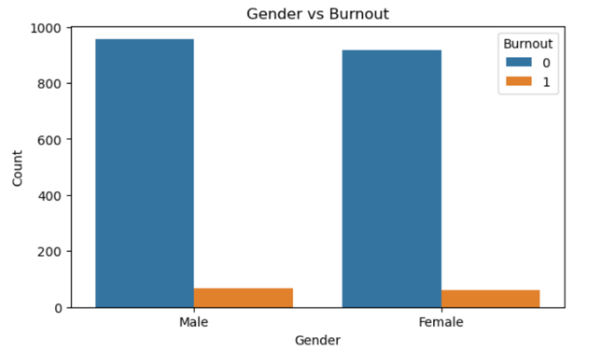 | 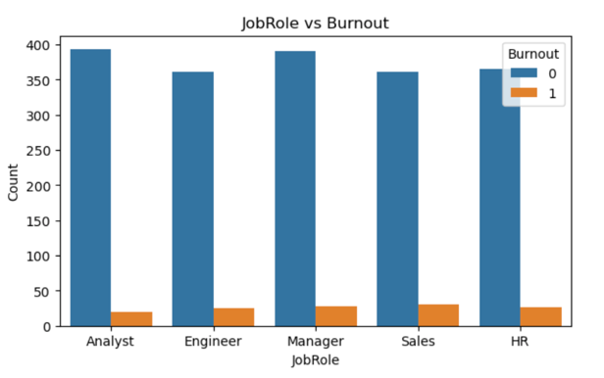

IV. Classification Methods
The analysis was implemented in Python using the Jupyter Notebook environment. Several open-source libraries were used for data preprocessing, visualization, model development, and evaluation:
- Pandas – for data loading, cleaning, manipulation, and summary statistics.
- NumPy – for numerical computations and array operations.
- Matplotlib – for creating charts and data visualizations.
- Seaborn – for enhanced statistical graphics, including heatmaps, boxplots, and histograms.
- Scikit-learn (sklearn) – for data preprocessing, train-test splitting, feature scaling, machine learning model implementation, and evaluation metrics. The classification algorithms implemented included Logistic Regression, Decision Tree, Random Forest, K-Nearest Neighbours (KNN), Support Vector Machine (SVM), Gradient Boosting, and Naïve Bayes. (Pedregosa et al., 2011)
- Imbalanced-learn (imblearn) – for applying the Synthetic Minority Oversampling Technique (SMOTE) to address class imbalance in the training dataset.
All models were trained and evaluated using the same training and testing datasets to ensure a fair comparison. Model performance was assessed using Accuracy, Precision, Recall, F1-score, ROC-AUC, and Confusion Matrices

-Logistic Regression
-Decision Tree
-Random Forest
-K-Nearest Neighbours
-Support Vector Machine
-Gradient Boosting
-Naïve Bayes.

Logistic Regression(Before and After SMOTE):
The Logistic Regression model achieved an accuracy of 96.00% before SMOTE, with a precision of 77.78%, recall of 53.85%, and an F1-score of 0.6364. Although the model demonstrated strong overall accuracy, it failed to identify nearly half of the employees experiencing burnout. After applying SMOTE, recall increased dramatically to 100%, meaning every burnout case in the test set was correctly identified. However, precision decreased to 48.15%, reducing the overall accuracy to 93.00%. This illustrates the common trade-off associated with oversampling, where improved sensitivity results in more false-positive predictions.
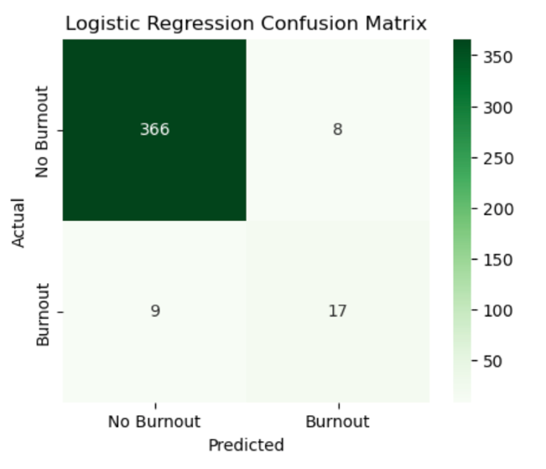 | 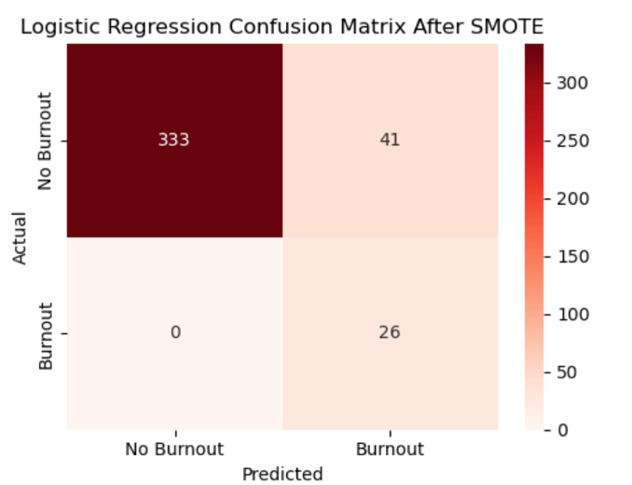

Decision Tree:
The Decision Tree classifier achieved perfect performance across all evaluation metrics, including 100% accuracy, precision, recall, F1-score, and ROC-AUC. The resulting tree had a depth of only three levels and four terminal leaves, indicating that the model did not overfit the data despite achieving perfect classification. The synthetic nature of the dataset and the strong separation between burnout and non-burnout employees likely contributed to this performance.
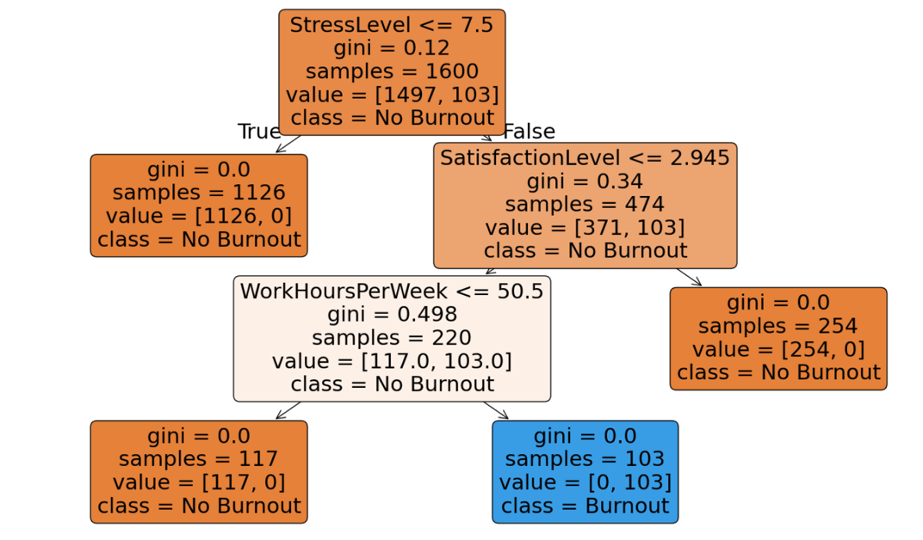

Random Forest:
Random Forest also achieved perfect classification performance, correctly classifying every employee in the testing dataset. As an ensemble of decision trees, Random Forest effectively captured the relationships between burnout and the predictor variables, producing perfect scores across all evaluation metrics. This model is generally robust when class imbalance is present. (Jonna, 2025)
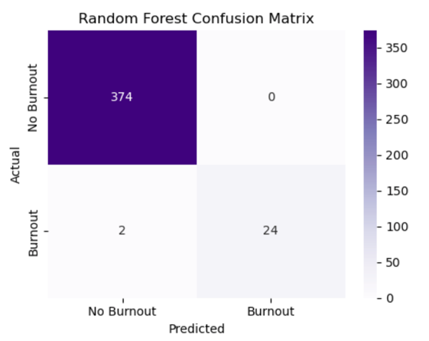

K-Nearest Neighbours(KNN) Before and After SMOTE:
The KNN classifier achieved an accuracy of 92.25% before SMOTE and demonstrated very high recall (96.15%), successfully identifying most burnout cases. However, precision remained relatively low (45.45%), indicating many false-positive predictions. Following SMOTE, KNN performance deteriorated considerably. Accuracy declined to 79.50%, recall decreased to 55.56%, and the F1-score fell to 0.4225. These results suggest that KNN was highly sensitive to the synthetic observations introduced during oversampling and was therefore not well suited to this dataset.

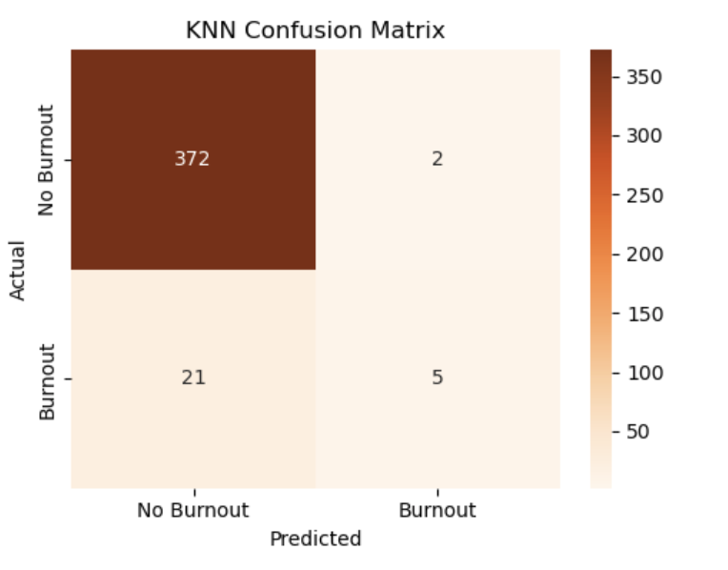 | 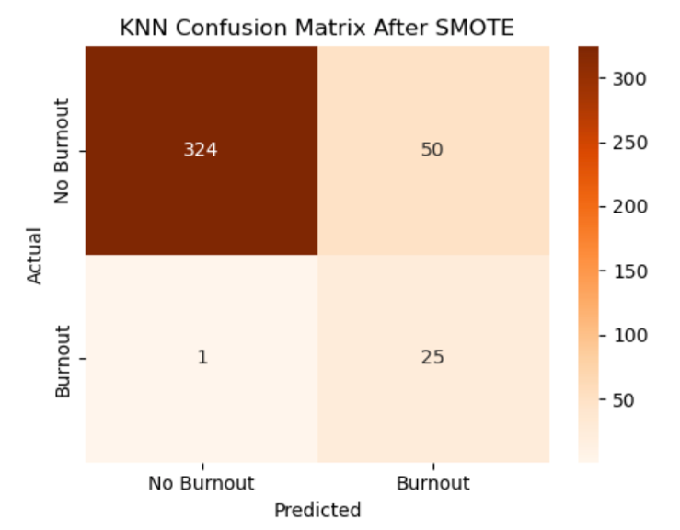

SVM:
The Support Vector Machine classifier achieved an accuracy of 95.75% and the highest precision (84.62%) among the non-tree-based models. However, recall remained relatively low (42.31%), indicating that many employees experiencing burnout were incorrectly classified as non-burnout. Consequently, the F1-score was 0.5641, suggesting that the model favoured precision over recall.
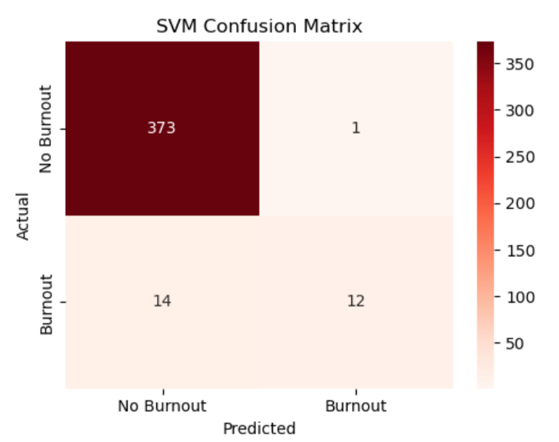
Gradient Boosting Before and After SMOTE:
Gradient Boosting achieved perfect performance both before and after SMOTE, producing 100% accuracy, precision, recall, F1-score, and ROC-AUC. Since no improvement was observed after oversampling, the results indicate that the algorithm was already capable of accurately separating the burnout classes using the original training data. This model is also adapted to imbalanced datasets. (APXML, n.d.).
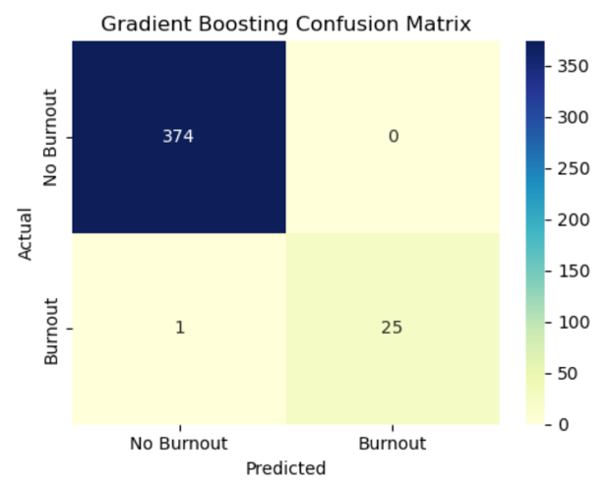 | 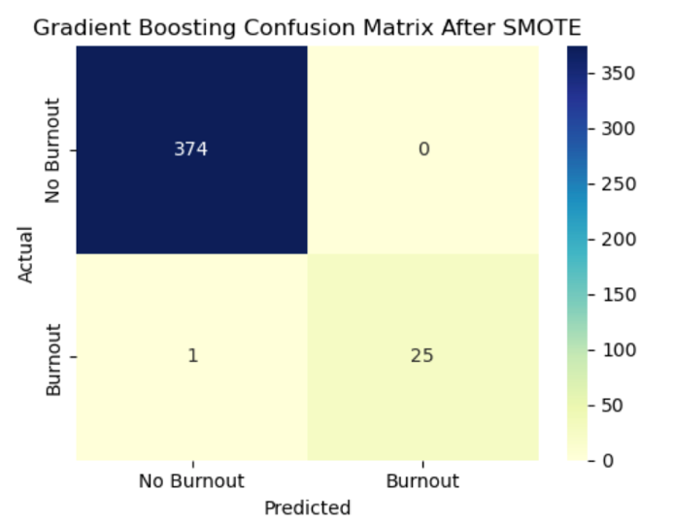

Naïve Bayes Before and After SMOTE:
Naïve Bayes achieved an accuracy of 97.00% before SMOTE and perfect precision (100%), but recall was limited to 53.85%, indicating that many burnout cases were missed.
After applying SMOTE, recall improved substantially to 80.77%, while precision remained relatively high (80.77%). Consequently, the F1-score increased from 0.7000 to 0.8077, making Naïve Bayes one of the few models that clearly benefited from oversampling.

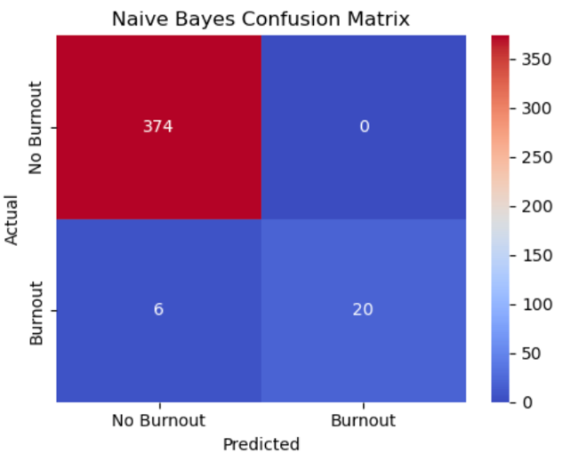 | 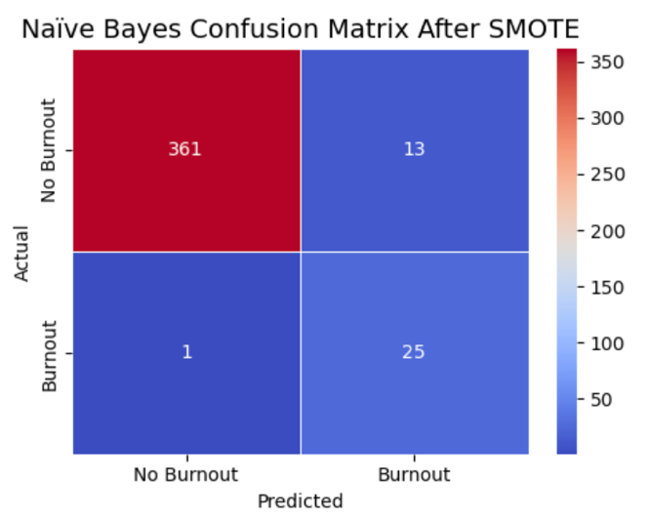

V. Model Training, Evaluation, and Comparison:
Accuracy: Measures the proportion of correctly classified observations.
Precision: Measures the proportion of predicted burnout cases that were actually burnout cases.
Recall (Sensitivity): Measures the proportion of actual burnout employees correctly identified.
F1-score: The harmonic mean of precision and recall, providing a balanced performance measure for imbalanced datasets.
ROC-AUC: Measures the model's ability to distinguish between burnout and non-burnout employees across different classification thresholds.
Confusion Matrix: Summarizes true positives, true negatives, false positives, and false negatives for each classifier.
Model | Accuracy | Precision | Recall | F1 Score | ROC-AUC
Logistic Regression | 0.9600 | 0.7778 | 0.5385 | 0.6364 | 0.6364
LR_SMOTE | 0.9300 | 0.4815 | 1.0000 | 0.6500 | 0.6500
Decision Tree | 1.0000 | 1.0000 | 1.0000 | 1.0000 | 1.0000
Random Forest | 1.0000 | 1.0000 | 1.0000 | 1.0000 | 1.0000
KNN | 0.9225 | 0.4545 | 0.9615 | 0.6173 | 0.6173
KNN_SMOTE | 0.7950 | 0.3409 | 0.5556 | 0.4225 | 0.4225
SVM | 0.9575 | 0.8462 | 0.4231 | 0.5641 | 0.5641
Gradient Boosting | 1.0000 | 1.0000 | 1.0000 | 1.0000 | 1.0000
GB_SMOTE | 1.0000 | 1.0000 | 1.0000 | 1.0000 | 1.0000
Naive Bayes | 0.9700 | 1.0000 | 0.5385 | 0.7000 | 0.7000
NB_SMOTE | 0.9750 | 0.8077 | 0.8077 | 0.8077 | 0.8077
Overall, the tree-based algorithms—Decision Tree, Random Forest, and Gradient Boosting—produced the strongest predictive performance, achieving perfect classification across all evaluation metrics. These models successfully identified every employee experiencing burnout without generating any false-positive predictions. The excellent performance is likely attributable to the synthetic dataset, in which burnout is strongly associated with a small set of highly informative variables, particularly Stress Level and Satisfaction Level.
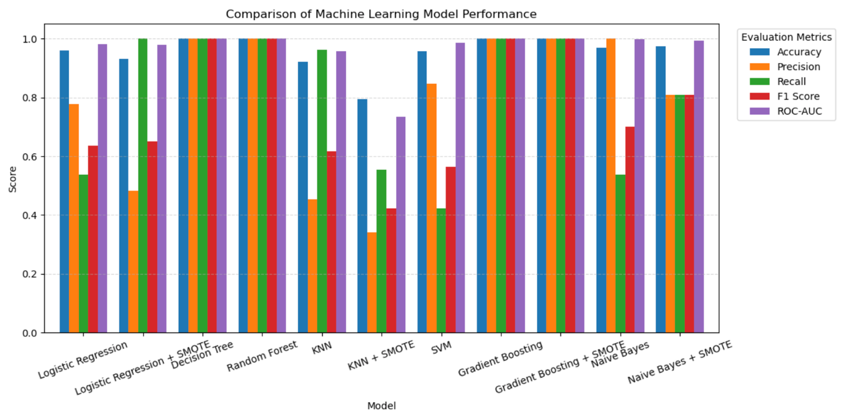
Among the non-tree-based models, Logistic Regression and Naïve Bayes benefited from SMOTE through improved recall. Logistic Regression after SMOTE correctly identified every burnout case, but experienced a substantial reduction in precision because of increased false positives. In contrast, Naïve Bayes achieved a better balance between precision and recall after oversampling, resulting in a higher F1-score.
KNN demonstrated the weakest overall performance. Although it initially achieved high recall, oversampling undermined its ability to distinguish between burnout and non-burnout employees, resulting in the lowest accuracy, F1-score, and ROC-AUC among all models.

VI. Discussion, Challenges, and Limitations
This study demonstrated that machine learning algorithms can effectively predict employee burnout using demographic, workplace, and well-being variables. Exploratory Data Analysis showed that Stress Level, Satisfaction Level, and Work Hours Per Week were the strongest predictors of burnout. Among the evaluated models, Decision Tree, Random Forest, and Gradient Boosting achieved the best performance, each obtaining perfect scores for Accuracy, Precision, Recall, F1-score, and ROC-AUC. The shallow Decision Tree (depth = 3 with four terminal leaves) suggests that the excellent performance was due to the strong separability of the synthetic dataset rather than model overfitting. Logistic Regression and Naïve Bayes benefited from SMOTE through improved recall, while KNN performed poorly after oversampling, indicating that the effectiveness of SMOTE depends on the classification algorithm.
The primary challenge encountered during this project was the severe class imbalance in the original dataset, in which burnout cases accounted for only a small proportion of observations. This made accuracy alone an insufficient evaluation metric, requiring additional measures such as Precision, Recall, F1-score, ROC-AUC, and Confusion Matrices to properly assess model performance. Another challenge was ensuring consistent preprocessing across different algorithms, as some models required feature scaling while tree-based models did not.
This study has several limitations. First, the dataset is synthetic, meaning that the relationships between variables are likely more distinct than those found in real organizational data, which may explain the exceptionally high performance of the tree-based models. Second, only a limited number of employee characteristics were available, whereas burnout is also influenced by factors such as organizational culture, leadership, workload, engagement, and work-life balance. Finally, model evaluation was based on a single train-test split; additional validation techniques, such as k-fold cross-validation and hyperparameter tuning, could improve the reliability and generalizability of the results. Future research should evaluate these models using real Human Resources datasets and investigate more advanced ensemble methods to develop robust decision-support tools for predicting employee burnout.

VII. Conclusion
This project successfully developed and compared seven machine learning classification algorithms to predict employee burnout using a synthetic Human Resources dataset. The analysis included data preprocessing, exploratory data analysis, feature encoding, model training, and evaluation before and after applying the Synthetic Minority Oversampling Technique (SMOTE).
The results demonstrated that Decision Tree, Random Forest, and Gradient Boosting achieved the highest predictive performance, each obtaining perfect scores across all evaluation metrics. Their excellent performance indicates that tree-based algorithms effectively captured the relationships between employee characteristics and burnout within this synthetic dataset. Logistic Regression and Naïve Bayes also benefited from SMOTE, improving recall, while KNN showed reduced performance after oversampling, illustrating that the impact of SMOTE varies across classification algorithms.
Overall, this study highlights the potential of machine learning as a decision-support tool for Human Resources by enabling early identification of employees at risk of burnout. Early detection can support timely interventions that improve employee well-being, productivity, and retention. However, because the analysis was conducted on a synthetic dataset, the findings should be interpreted with caution. Future research should validate these models using real organizational HR data, incorporate additional workplace and behavioural variables, and apply advanced validation and model optimization techniques to improve the robustness and generalizability of burnout prediction models

VIII. References
- Chawla, N. V., Bowyer, K. W., Hall, L. O., & Kegelmeyer, W. P. (2002). SMOTE: Synthetic Minority Over-sampling Technique. Journal of Artificial Intelligence Research, 16, 321–357.
- Kaggle. (n.d.). Synthetic HR Burnout Dataset. https://www.kaggle.com/datasets/ankam6010/synthetic-hr-burnout-dataset
- Maslach, C., & Leiter, M. P. (2016). Understanding the burnout experience: Recent research and its implications for psychiatry. World Psychiatry, 15(2), 103–111.
- Pedregosa, F., et al. (2011). Scikit-learn: Machine Learning in Python. Journal of Machine Learning Research, 12, 2825–2830.
- Lemaître, G., Nogueira, F., & Aridas, C. K. (n.d.). SMOTE. imbalanced-learn documentation. https://imbalanced-learn.org/stable/references/generated/imblearn.over_sampling.SMOTE.html
- GeeksforGeeks. (2025, July 23). SMOTE for imbalanced classification with Python. https://www.geeksforgeeks.org/machine-learning/smote-for-imbalanced-classification-with-python/
- Jonna, S. (2025, January 8). SMOTE and Random Forest: Cracking the code for imbalanced data. Medium. https://medium.com/@sujeevana.jonna/smote-and-random-forest-cracking-the-code-for-imbalanced-data-11969dc3acd4
- APXML. (n.d.). Handling imbalanced data in boosting. APXML. https://apxml.com/courses/mastering-gradient-boosting-algorithms/chapter-7-boosting-advanced-topics-customization/handling-imbalanced-data-boosting
- Data Science Foundry. (n.d.). Data Science Foundry [Instagram profile]. Instagram. https://www.instagram.com/datasciencefoundry/

